**1. Background**

Goal: We will try to use regression analysis method to find the correlation relationship between the major airline stock market and the oil prices.

(1)Airline industries

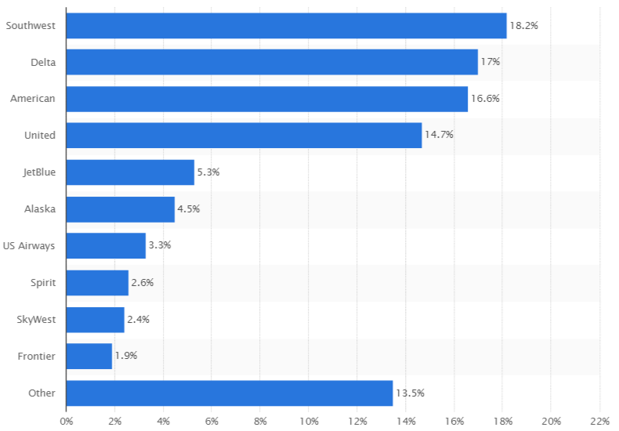

Chart1: Airline Domestic Market Share

"U.S. Domestic Market Share of Leading Airlines 2015 | Statistic." Statista. Web. 01 Aug. 2016. <http://www.statista.com/statistics/250577/domestic-market-share-of-leading-us-airlines/>.

(3)Three major airlines

Southwest Airlines Co. (NYSE: LUV) is a major U.S. airline, the world's largest low-cost carrier, headquartered in Dallas, Texas.

Delta Airlines, Inc. ("Delta"; NYSE: DAL) is a major American airline, with its headquarters and largest hub at Hartsfield–Jackson Atlanta International Airport in Atlanta, Georgia.

American Airlines, Inc. (AA), commonly referred to as American, is a major American airline headquartered in Fort Worth, Texas.

Southwest Airlines, Delta Airlines and American Airlines have already owned 51.8% of the domestic airline market. So, in this research, we choose these three company to represent the whole American airline industry.

(2)The relationship between airlines and oil prices

Chart: Oil Consumption of three major companies in 2015

|  |  |  |
| --- | --- | --- |
|  | Consumption (thousand gallons) | Cost (thousand dollars) |
| Southwest Airlines | 1,900,738 | 3,428,321 |
| Delta Airlines | 3,368,545 | 7,786,063 |
| American Airlines | 3,035,736 | 4,942,318 |

"RITA | BTS | Transtats." RITA | BTS | Transtats. Web. 01 Aug. 2016. <http://www.transtats.bts.gov/fuel.asp?pn=1>.

Oil consumption is a major expense for an airline company. Take Delta Airlines as a good example: In 2015, it spent seven billion and seven hundred and eight six million on buying oil.

**2. Crude Oil Data**

(1) Initial data

Here we collected data from US. Energy Information Administration on West Texas Intermediate (WTI) crude oil price from May 2010 to May 2016 (6 years)

"Table Definitions, Sources, and Explanatory Notes." Table Definitions, Sources, and Explanatory Notes. Web. 01 Aug. 2016. <http://www.eia.doe.gov/dnav/pet/TblDefs/pet_pri_spt_tbldef2.asp>.

(2)Data description

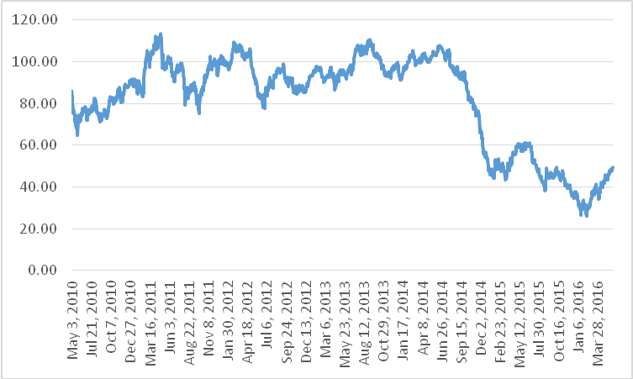

Chart: Line Chart of Crude oil price

According to the line Chart of Crude oil price, the oil price was floating up and down between May 2010 and June 2014. From June 2014, the oil price went down sharply.

Chart: Descriptive Statistics on the Crude Oil Price



The mean value of crude oil price from May 2010 to May 2016 is 81.7730. Also the variance is 500.291, which suggest the data is not around the mean. Experimental value of the skewness is-0.879, which means the mass of the distribution is concentrated on the right of the figure. . Kurtosis of the data is -0.549, which indicated that the curve is slightly flat and has a little bit longer tails on both side (The Kurtosis of normal distribution is 0.)

**3. Airline Companies Data**

(1) Initial data

Here we collected data from yahoo finance on Delta Airlines, American Airlines and Southwest Airlines’ daily stock adjust close price from May 2010 to May 2016 (6 years). Totally, we have 1531 daily data for each company.

Reference: [http://finance.yahoo.com](http://finance.yahoo.com/q/hp?s=DAL)

(2) Data description

Chart: Line Chart of Stock Price of Three Major Airline Company

According to the chart, the stock price of three major airline company have the similar tendency. All the three stock price kept steady in the first three years and then went up step by step in the last three years.

**4. Correlation Test**

(1) Chart: Line Chart of Stock Price of Three Major Airline Company and Oil Price

According to this chart, the stock prices of the airline industry have the opposite tendency with the oil price. Between May2010 and May 2014, all stock price and oil price were relatively steady. However, starting from May 2014, the oil price went down sharply in the past two years, on the contrary, and the stock price went up sharply in the past two years.

(2) Pearson Correlation Coefficient

a. Definition

In statistics, the Pearson product-moment correlation coefficient is a measure of the linear correlation between two variables X and Y, giving a value between +1 and −1 inclusive, where 1 is total positive correlation, 0 is no correlation, and −1 is total negative correlation.

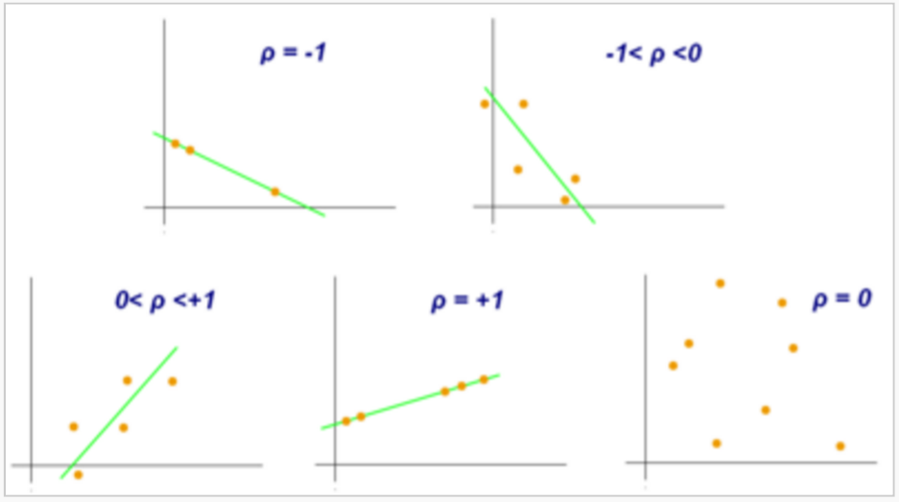

Chart: Examples of scatter diagrams with different values of correlation coefficient (ρ)

So if we have one dataset {*x*1,...,*xn*} containing *n* values and another dataset {*y*1,...,*yn*} containing *n* values then that formula for *r* is:

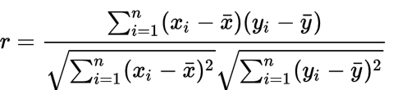

:sample mean ;sample mean

b. Pearson Correlations Test

|  |  |  |  |  |
| --- | --- | --- | --- | --- |
|  |  | Delta Airlines Stock Price | American Airlines Stock Price | Southwest Airlines Stock Price |
| Oil Price | Pearson Correlation | -0.687 | -0.612 | -0.782 |
| P Value | 0.000 | 0.000 | 0.000 |

|  |  |  |  |  |
| --- | --- | --- | --- | --- |
|  |  | Ln(Delta Airlines Stock Price) | Ln(American Airlines Stock Price) | Ln(Southwest Airlines Stock Price) |
| Ln(Oil Price) | Pearson Correlation | -0.795 | -0.612 | -0.782 |
| P Value | 0.000 | 0.000 | 0.000 |

Correlation is significant at the 0.05 level (one-tailed).

According to the chart, the Pearson correlation are -0.687,-0.612 and-0.782. And also the P value is smaller than the significant number 0.05, which means all the three Pearson correlation are accurate. All the correlations are negative, which indicate that the crude oil prices and the airline stock prices have negative correlation relationships.

**5. Regression line Model**

(1) Notation definition

|  |  |  |
| --- | --- | --- |
| Notation | Value | Unit |
| X | Crude oil price | Dollar |
| A | Airlines Share Price | Dollar |

(2)Assumption

a. We use the logarithm regression line to describe the relationship between two variables.

b. Crude oil price is the independence variable; airline stock adjust closed price is the dependence variable.

c. The model we set up is $\ln\left(A\right)=α+β\ln\left(x\right)+ε$ ( $α$ is constant number, $β$ is coefficient of ln(x), $ε is random error$)

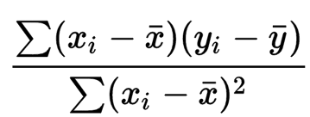(3)Calculation

=

=

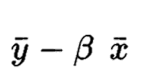

|  |  |
| --- | --- |
| {\displaystyle {\bar {x}}}x | observed value independence variable |
| $$y_{i}$$ | observed value dependence variable |
|  | Mean value of independence variable |
|  | Mean value of dependence variable |

(4)Estimate Regression Model

For more convenience, we use the SPSS software to estimate the regression line.

a. Delta Airlines Regression Model

Chart: Delta Airlines coefficient result

|  |  |  |  |  |
| --- | --- | --- | --- | --- |
|  | Unstandardized Coefficients | | t | Sig. |
| Coefficient | Std. Error |
|  | -32.248 | .819 | -39.363 | .000 |
|  | 164.700 | 3.578 | 46.026 | .000 |

Because $β$ is -32.248, which means every 1 unit change in the lnX can cause 32.248 unit change in the lnA. Oil price does big contribution to the Delta Airline share price.

Chart: Delta Airlines Scatter Plot

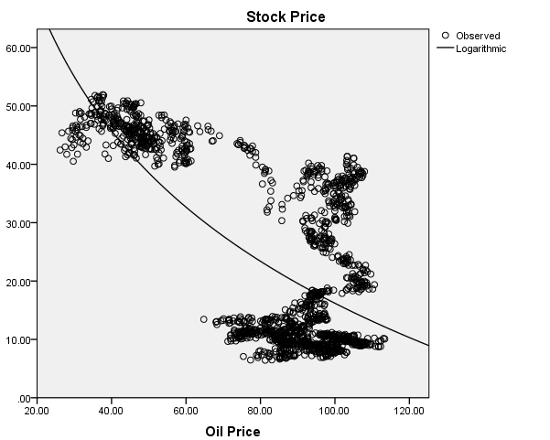

Those sample points distribute on both sides of the regression line.

b. American Airlines Regression Model

Chart: coefficient result

|  |  |  |  |  |
| --- | --- | --- | --- | --- |
|  | Unstandardized Coefficients | | t | Sig. |
| Coefficient | Std. Error |
|  | -28.745 | .917 | -31.348 | .000 |
|  | 148.598 | 4.005 | 37.102 | .000 |

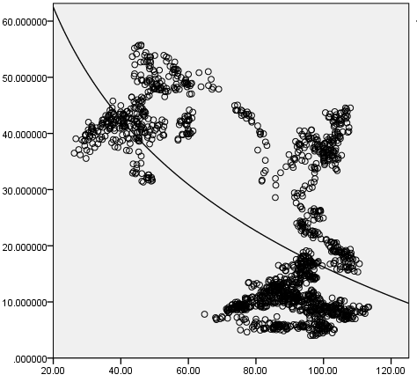

(4) Coefficient of determination

The coefficient of determination indicates the proportion of the variance in the dependent variable that is predictable from the independent variable.

Formula:

$$R^{2}=\frac{\sum_{i}{{(y_{i}-\overline{y})}^{2} }}{\sum_{i}{{(f_{i}-\overline{y})}^{2} }}$$

$$\overline{y}: the mean of the observed data$$

$$y_{i}: the observed value$$

$$f_{i}: the predicted value$$

|  |  |  |
| --- | --- | --- |
| R | R Square | Std. Error of the Estimate |
| .625 | .391 | 12.078 |

The coefficient of determination (R Square)=0.503. This means that 50.3% of variation in Delta Airline’s share prices can be explained by variation in Crude oil prices.

c. Southwest Airlines Regression Model

|  |  |  |  |  |
| --- | --- | --- | --- | --- |
|  | Unstandardized Coefficients | | t | Sig. |
| Coefficient | Std. Error |
|  | -31.239 | .610 | -51.192 | .000 |
|  | 157.237 | 2.665 | 58.992 | .000 |

Chart: coefficient result

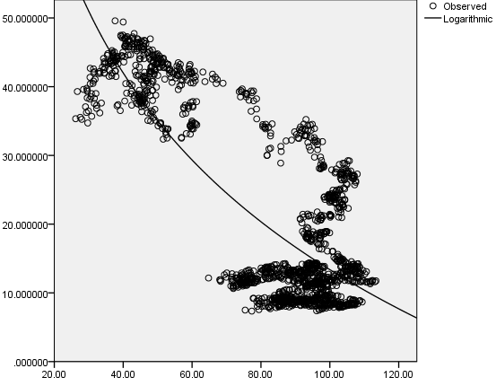

|  |  |  |
| --- | --- | --- |
| R | R Square | Std. Error of the Estimate |
| .795 | .632 | 8.038 |

(5) Models summary

Delta airlines model: $\ln\left(Y\right)=164.700-32.248\ln\left(X\right)$

American airlines model: $\ln\left(Y\right)=148.598-28.745\ln\left(X\right)$

Southwest airlines model: $\ln\left(Y\right)=157.237-31.239\ln\left(X\right)$

As we can see, all the three $β$ are negative, which means when the oil prices go up, it will cause dropping of stock prices. The crude oil prices and the airline stock prices have negative correlation relationships.

**6. Hypothesis testing**

We can usehypothesis testing to test the accuracy of those three model. Here we take Delta airlines’ model as an example.

|  |
| --- |
|  |

(1) The null hypothesis: The coefficient $β$ is equal to 0.

The alternative hypothesis: The coefficient $β$ is less than 0.

(2)We need to compare t value with the critical value

t=(coefficient-0)/standard error

c. $t_{β}$ =(-32.248-0)/0.819=-39.363;

(3) The probability level is 0.05. The freedom of degree is 1531*2-2=3058. The critical value for one tail is -1.96074008 which means the critical region is from infinity to -1.96074008. t value -39.363 does fall into the critical region We need to reject the null hypothesis and accept the alternative hypothesis.

(4) Coefficient range

As we know, the model is estimate model, so we can find the 95% confidence intervals for the coefficient range

$α$ = 164.6483.582*1. 96074008=(157.62462903,171.67137097)

$β$ =-32.2480.819*1. 96074008=(-33.85384613,-30.64215387)

(5) We also use the hypothesis test for American airlines’ regression model and Southwest airlines’ regression model, both of them pass the test.

**7. Conclusion**

First, according to the Pearson correlation result, we can find that the crude oil price and the airline stock prices have strong negative correlation relationships. Second, according to the analysis of regression models, we find that one unit change of lnx (nature log of oil price) can cause -28.745 to – 32.248 unit change of lnA (nature log of airline stock price). $β$ differs from different airline company, but it is always a negative number, which means oil prices and airline stock prices exist negative relationship.

Combining this two results, our conclusion is that oil price is the common factor to affect the stock price of the airline industry. When the oil price goes up, it causes the stock price of the airline industry decreasing. Oppositely, when the oil price drop, it causes the stock price of the airline industry increasing.